## **3.2. Project Management Methodology**

Project management processes fall into five steps: Initiation, Planning, Implementation, Monitoring / Control and Closure. It can be widely used to regulate the complex processes in software development projects. There are various project management methodologies such as Waterfall, Agile, Scrum, Scrumban, PRiSM, Prince2 and Kanban which are mainly used in many software projects. From these earlier project management methodologies, we select the Prince2 methodology for the project. It known as a “full stack” waterfall project management.

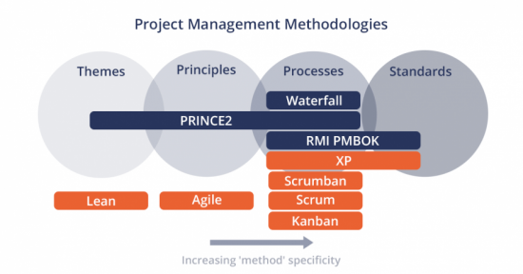

Figure 14:Project Management Methodologies

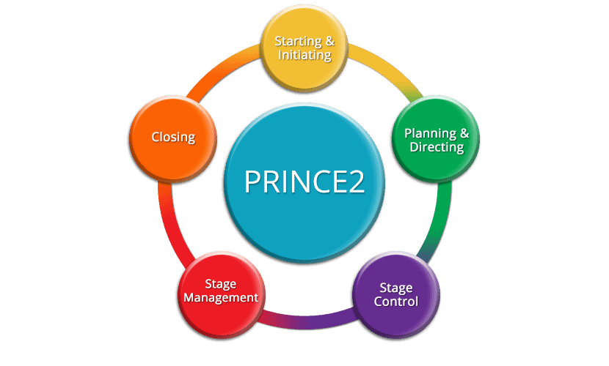

Figure 15:Prince2 Methodology

It is a high-level process which consists of a highly process-oriented series (Steps), to plan, implement, control and review the project. Prince2 describes every input and outputs step by step and offers a framework for project management. (axelos, 2019)

## **3.3. Testing Methodology**

In our project Black box Testing involves for the testing a System without any internal working knowledge of it . a tester provides an input an observe under surveillance which are the outputs generate by a system under a test also we use white board testing for internal structures and working of an application.

Figure 16:black box testing

Figure 17:White box testing

## **3.3. Code Methodology**

Process model agile use for Coding Methodology.

Figure 18:Process model agile